Important request for Bovingdon Residents

Do you want to protect our Bovingdon Wildlife from future development? Urgent information needed
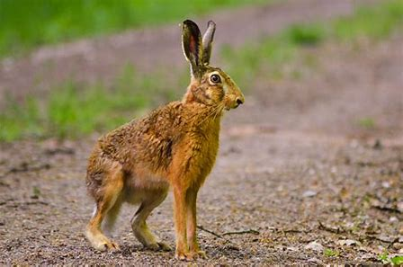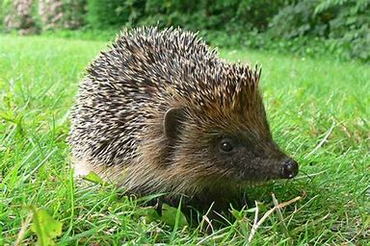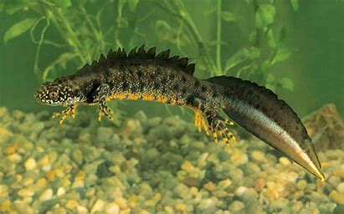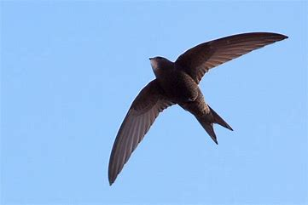
What wildlife have you seen in Bovingdon over the last 18 months?
Many of you will have recently contributed to the preparation of the Bovingdon Neighbourhood Plan. An important part of this is the work of a small team of volunteers on a key task to try and protect our most special local greenspaces from inappropriate local development. We may need more houses but it is important that new developments are built with wildlife in mind. This can be achieved with care but we need to identify what we have now and which areas need to be protected first.
The wonders of Bovingdon
The Parish area has wonderful green lanes, footpaths, fields and woodlands that provide fresh air and exercise for you and good habitat for a huge range of wildflowers, shrubs and trees and all the birds, insects and animals that rely on those habitats. In addition, the Parish is quite unique in this highly populated area by being a hub between crucial wildlife sites outside the boundary in all directions. Chipperfield Common, the Chess Valley, Westbrook Hay and miles of green fields towards Tring Park are key examples. Our own wildlife will often need safe access to these areas to prevent ‘in-breeding’ of isolated populations. At the same time, as the human population is increasing steadily, there is an inevitable call to increase housing. It is becoming increasingly evident that if we want to halt the drastic reductions in wildlife across the Country then we must find ways to ensure that new building does not take away key habitats. Most importantly, we must maintain what we call ‘wildlife corridors’. The reason so many species are declining is that they are isolated from other habitats.
If you are not sure of the Bovingdon Boundaries please see the map below:
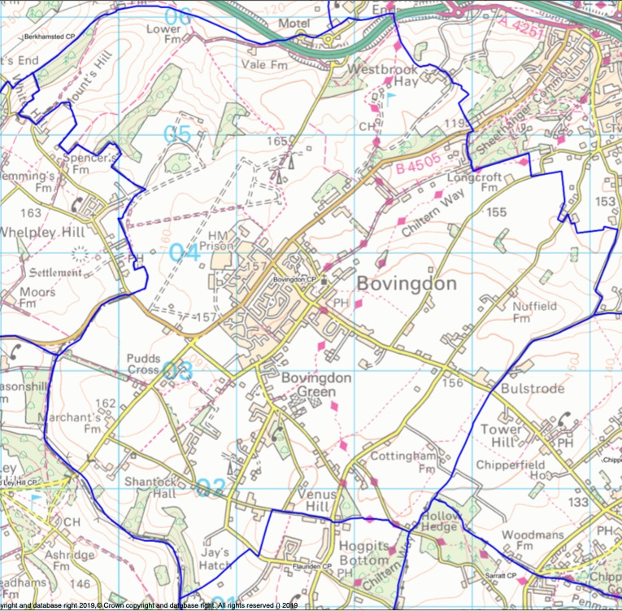
What do we need
The team has already been in touch with Wildlife Trusts etc and knows a lot about Bovingdon’s wildlife and where it is, but you may know more, in fact some of you may have crucial information. We need feedback from you and your families about certain key species you may have seen in Bovingdon over the last 18 months. This is not only important for the future, but your family may also find it good fun to contribute – a bit of citizen science. It could also include fast disappearing species you may have seen in your gardens, such as hedgehogs, swifts and toads. Much of the detail we need is for species that are only seen in summer. We are relying on your memories for these from 2018 and 2019 because we need to try and complete the project in March 2020.
Why do we need this?
This is a really important one-off project because, across the country, we are at last beginning to realise that separation and reduction of breeding grounds for animals and insects, in particular, creates confinement that can eventually lead to extinction. Once a species of wildflower or animal disappears from an area it can be almost impossible to get it back. The knock-on effect through the food chain and on pollination can be drastic. So, part of this work is to try and ensure that we know what species are out there, where they are and then identify wildlife corridors and breeding areas for them such as meadows, big hedges and wildflower rich field margins.
Is there any point, “won’t development happen anyway?” Yes, there is a point, this exercise is important as the Neighbourhood Plan will give your Parish Council more leverage in future AND by highlighting special species and places NOW it can help ensure future planning policy takes it into account at an early stage.
We don’t need to know every species, it is those that are declining quickly that we need to concentrate on for now. If we can protect them it is likely that most other species will benefit too. If you would like to contribute then please see the form below.
Please don’t be put off by all the species here. Just one sighting of a single hedgehog in your garden or a record of where our fast-declining Swifts may be nesting could help to map where they have managed to hold on against the odds.
What about special wildlife habitats that I know locally?
If you know a little ‘haven’ that you feel needs to be protected then please add that to your return.
What if I own Land – I might be shooting myself in the foot?
The overall Neighbourhood Plan is about getting a balanced approach to recreation land, wildlife habitat and development. You may own special land that you want protected anyway so this is the chance to say. If, on the other hand, you feel that there is future development potential in your land then it may have more chance of a successful planning application in due course if it is clear that care with just a part of that land can contribute to long term wildlife protection and enjoyment for the future residents.

BOVINGDON PARISH COUNCIL email: office@bovingdonparishcouncil.gov.uk
Wildlife Project Report Form
Your Name _____________________Telephone_________________
Your details are so that we can contact you in the case of a very special sighting. The information will not be published or retained.
To be returned to the Parish Office in the High Street please by 28th February – can be by email.
Time of Year: Sightings last summer are needed for many species
Location – must be within the Bovingdon Boundary. If it is a garden just say which street. If it’s a field or footpath please try your best to describe the location. WE DO NOT NEED SIGHTINGS FROM THE BRICKWORKS OR ST LAWRENCE CHURCHYARD AS WE HAVE THEM
Numbers – Many sightings will be single but if more and if regular then please estimate numbers
** Knowledge of nest sites needed so extra boxes can be used nearby to help the species breed
SPECIES | LOCATION AND MONTH | NUMBER
BIRDS
SWIFT - FLYING | Summer
SWIFT – NEST SITE ** | Summer
CUCKOO | Summer
YELLOW HAMMER
CORN BUNTING
MARSH TIT
BULLFINCH
HOUSE MARTIN | Summer
HOUSE MARTIN - NEST SITE **
COMMON PARTRIDGE
WILLOW WARBLER | Summer
SPOTTED FLYCATCHER | Summer
TAWNY, LITTLE OR BARN OWL
OTHER SCARCE SPECIES
ANIMALS, REPTILES, AMPHINIANS
HEDGEHOG
HARE
STOAT
WEASEL
GRASS SNAKE
SLOW WORM
TOAD
GREAT CRESTED NEWT
OTHER SCARCE SPECIES:

SPECIES | LOCATION AND MONTH | NUMBER
BUTTERFLIES AND MOTHS
MARBLED WHITE | Summer
ANY OF THE SKIPPER SPECIES | Summer
BURNET COMPANION MOTH | Summer
MOTHER SHIPTON MOTH | Summer
LARGE MAGPIE MOTH | Summer
GARDEN TIGER MOTH | Summer
OTHER SCARCE SPECIES:
WILDFLOWERS
ANY ORCHIDS
BIRDSFOOT TREFOIL
COWSLIP
OX EYE DAISY
LARGE FIELD SCABIOUS
RAGGED ROBIN
DOG VIOLET
WHITE OR RED CAMPION
ANY OTHER SPECIAL WILDFLOWERS:
ANY OTHER SPECIAL SPECIES
ANY SPECIAL WILDLIFE HAVENS | PLEASE GIVE PRECISE LOCATION

